|  |  |  |
| --- | --- | --- |
| **Lyng Primary School P.E Knowledge Organiser** | | |
| **Topic: Tag-Rugby** | Year 4 | Autumn 2 |





**Enquiry Questions**

* How can we change direction quickly?
* What way are we allowed to throw the ball to make as pass?
* How do we complete a try?
* What are the best techniques to use when attacking the defence?
* What is offside in rugby?
* Can we transfer skills into a game situation?

|  |  |
| --- | --- |
| **Key words** | |
| **Spelling** | **Definition** |
| Try Zone | Try Zone is the area where the ball needs to be placed in order to score a try. |
| Try | Another name for a goal or point, when a try is scored points are added to the teams total. |
| Tag | A non-contact way of tackling when a player is tagged they must pass the ball on & put their tags back on. |
| Attacking | Attacking the defending team in order to attempt to score a Try. |
| Free pass | Free pass is when the opposition have made a forward pass which isn’t allowed, so a free pass is awarded to the other team. |
| Pop Pass | Is a type passing technique used in rugby. |

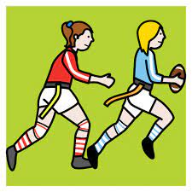

***“There is no “I” in TEAM”***

**– Mav Levy**

|  |  |  |
| --- | --- | --- |
| **Lyng Primary School P.E Knowledge Organiser** | | |
| **Topic: Tag - Rugby** | Year 4 | Autumn 2 |

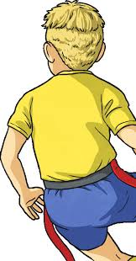

Learning Outcomes

* To practice change of direction when travelling at speed.
* To develop handling techniques when making passes.
* To develop attacking skills and understand how to make try.
* To develop attacking and defending skills and what techniques to use.
* To ensure we’ve got an understanding of game rules prior to next lesson putting skills into a game situation.
* To put skills into game play.

